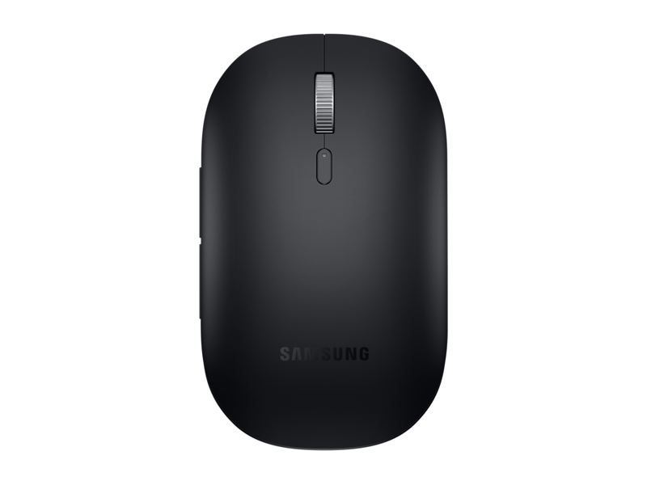

**Bluetooth Mouse Slim, Black**

**EJ-M3400 /EJ-M3400DBEGUS**

1.7 out of 5 stars, average rating value. Read 6 Reviews. Same page link.

1.7

(6)

Write a review

Share your product experience

**Samsung Easy pairing**

**High responsiveness & precise tracking**

**Wishlist**

**Color Black**

**[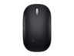](https://www.samsung.com/us/computing/computing-accessories/computers/bluetooth-mouse-slim--black-ej-m3400dbegus/)[[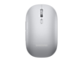](https://www.samsung.com/us/computing/computing-accessories/computers/bluetooth-mouse-slim--silver-ej-m3400dsegus/)](https://www.samsung.com/us/computing/computing-accessories/computers/bluetooth-mouse-slim--silver-ej-m3400dsegus/" \t "_self)**

shipping van icon

Get it by Dec. 18

**Delivery for:10001**

Price:

$59.99



**Log in now to earn up to 1.5%  
back in Samsung Rewards Points**

[**BUY NOW**](javascript:;)

**https://image-us.samsung.com/SamsungUS/home/store-locator/storepickup.png**

**Samsung store & curbside pickup**

Open now in Palo Alto, Los Angeles, Houston and New York City

**VIEW ALL STORES**

[**WHERE TO BUY**](https://www.samsung.com/us/computing/computing-accessories/computers/where-to-buy/bluetooth-mouse-slim--black-ej-m3400dbegus/EJ-M3400DBEGUS)

**Comfort for wherever you work**

Portable and elegant, the Bluetooth Mouse Slim lets you set up and get to work with all-day comfort. The sculpted design supports your hand for a good grip, and it's slim enough to slip into your laptop bag so you can keep it on hand.

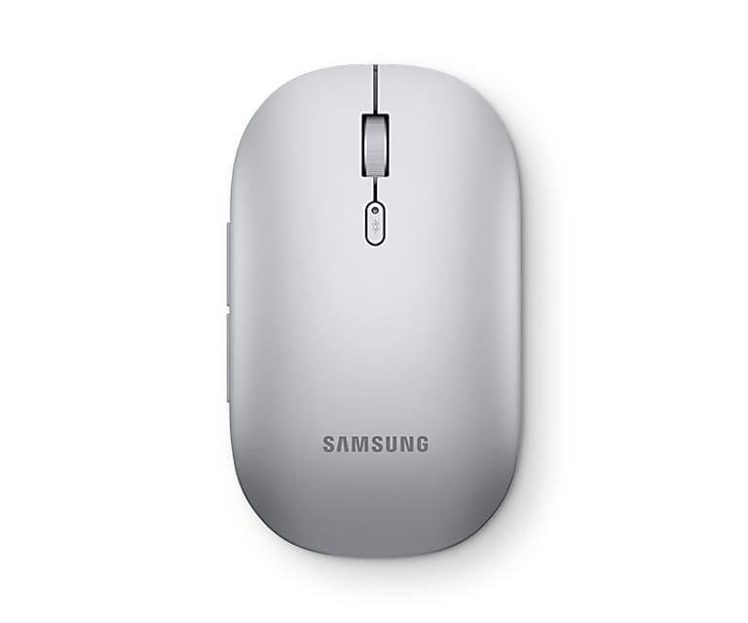

**Pairs up with ease**

Pairing the mouse is as easy as following the instructions in the pop-up on your laptop. When you put the mouse in pairing mode, your laptop will discover it, and you can quickly connect and get back on track with wireless comfort.

*\*Image simulated for illustration purposes. Actual UI may be different.*

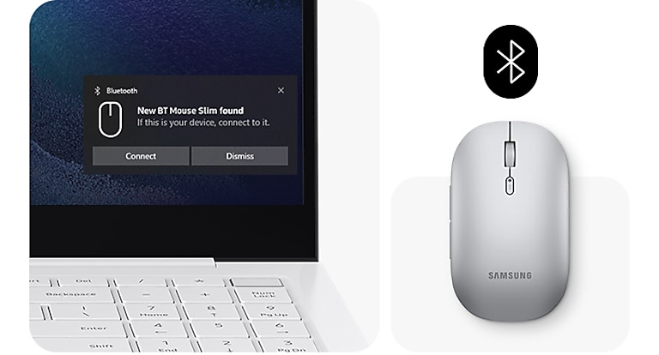

[**See All Specs**](javascript:void(0))

s